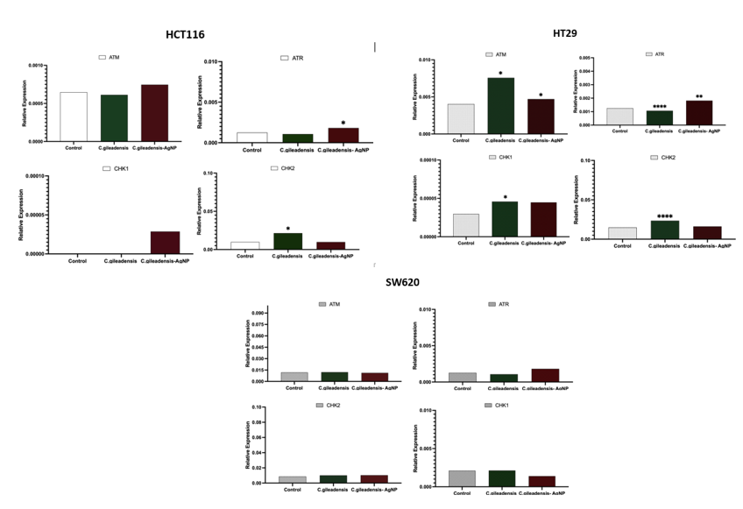

**Figure 5- Gene expression fold change in cell lines treated with *C. gileadensis extract and C. ligustica C. gileadensis AgNP extract* .**